**Keywords, Identifier, Literals, Operators and Expression Assignment**

1. Choose all valid identifiers

**a. int int**

**b. int _numvalue**

**c. float price_money**

**d. char name1234567890123456789012345678901234567890**

**e. char name value**

**f. char $name**

A. a. Invalid because keywords cannot be used

**b. Valid**

**c. Valid**

**d Invalid because it is too long**

**e. Invalid as there is space**

**f. Invalid should not start with $**

2. What is the meaning of the following keywords, show the usage

**a. auto**

**b. extern**

**c. volatile**

**d. sizeof**

**e. const**

A. Auto keyword automatically refers to the type of variable without declaration and allocates memory

**a. Extern keyword is used to refer to functions or variables that are defined in another file**

**b. Volatile keyword describes that the value of variable can be changed at any time**

**c. sizeof keyword gives the size of datatype or variable**

**d. const keyword is used for the variables that cannot be altered after initialization**.

3. Explain the difference between the following variables.

**a. char *ptr = “ABC”;**

**b. char arr[]=”ABC”;**

A. In a the ptr points to the ABC. IN b the array stores the string.

Can you manipulate the contents of ptr? Why?

**A. No we cannot manipulate the string but we can manipulate the ptr value to someother value**

Can you manipulate the contents of arr? Why?

**A. Yes we can manipulate the contents of arr by indexing**

Which one of the above is a string literal?

**A. Both the values are string literals. But in a it refers to the string literal and in b arr contains string literal**

4. Predict the output of the following code .

**A. 5 4**

**4 4**

5. Refer the code snippet. It fails with error. Fix it.

#include<stdio.h>

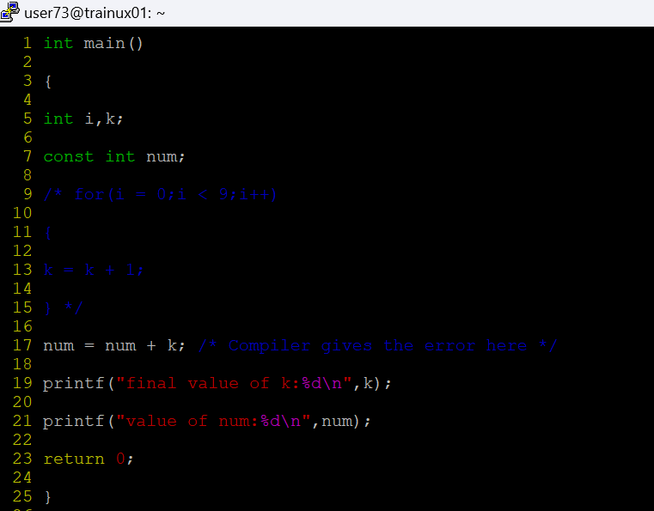

**A. The error here is a compilation error as it cannot update the value of num as it is constant. By removing the keyword const it works perfectly**

6. Consider the following code snippet. Evaluate the value of f1, f2 and f3.

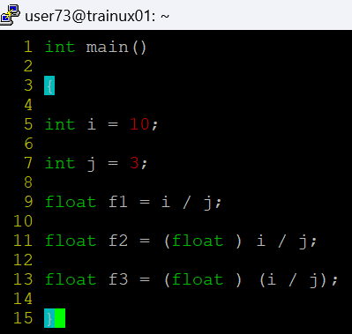

**A. F1= 3.00**

**F2= 3.33**

**F3 =3.00**